2020 N. C. Dental Opioid Update Course
(for 2021 Dental License Renewal)
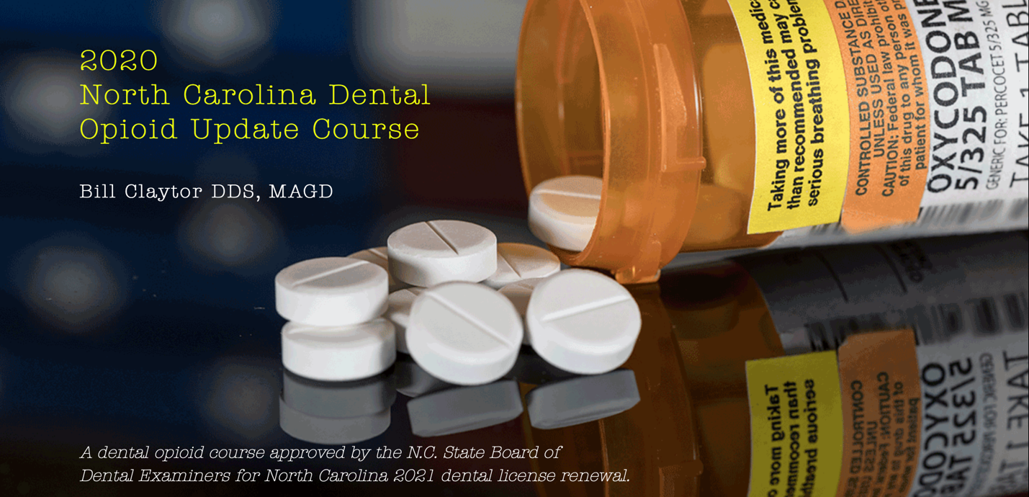
Hello everyone. Bill Claytor here.
I am pleased to announce our 4 remaining online N. C. Dental Opioid Update Courses for 2020 using the Zoom Virtual Meeting platform. Due to the continued issues surrounding the Coronavirus pandemic and the uncertainty of the hotels allowing us to have group meetings in the future, I have had to cancel the rest of our in-person Opioid Courses for 2020. Our 4 remaining online courses are approved by the North Carolina State Board of Dental Examiners for 1.5 hours of CE credit. Completion of this course in 2020 will fulfill the requirement of North Carolina dentists with a DEA license becoming compliant for dental license renewal for 2021. (Note: If you do not have a DEA license, you may take the course but it is not required for dental license renewal).
I want to personally invite you to one of our remaining courses if you still need to fulfill this requirement. I will strive to make this course informative, up to date and entertaining for you while relevant to your daily dental practices.
Hope to see you soon on Zoom!
Thank you!

Bill Claytor

Please register for one of our remaining course listings for 2020 below.
2020 Schedule for
Zoom Online Opioid Courses
Date | ZOOM Meeting | To Register, Click Below
August 20, 2020 | Online | August 20, 2020  Click to Register
September 17, 2020 | Online | September 17, 2020  Click to Register
October 8, 2020 | Online | October 8, 2020  Click to Register
December 1, 2020 | Online | December 1, 2020  Click to Register

About this Event

Register: ncdentalopioidcourse.com

Schedule for All Online Courses:
6:00 - 6:30 PM (EDT): Check-In
6:30 - 8:00 PM (EDT): Course (via ZOOM online conferencing)
8:00 PM (EDT): At the end of the course, attendees will take
post-event test to receive certificate of
completion*
*Certificate of completion will be physically mailed to each practitioner following the completion of the post-event test.

CE Credits: 1.5 Hours

Fee: $80 tuition/dentist

Email: ncdentalopioidcourse@gmail.com
Website: ncdentalopioidcourse.com
Facebook: N. C. Dental Opioids
Cell Phone: 704-473-4864

N.C. Dental Opioids
P.O. Box 454
Shelby, N.C. 28151

